SAMPLE PRESS RELEASE

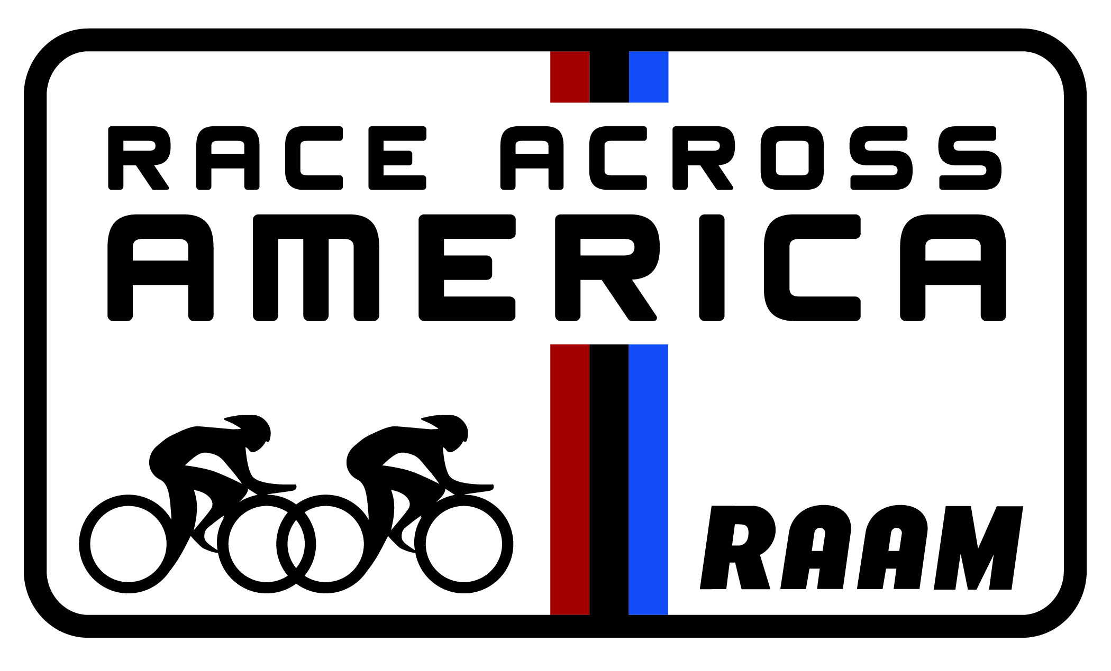

FOR IMMEDIATE RELEASE
Contact: Your Name
Your Email
Rick Boethling, RAAM
media@raceacrossamerica.org

Your Town Resident/Team Name Prepares for Bicycle Race of a Lifetime – Across the USA Your Name Will Race From Coast-to-Coast (or) Your Name Will Race to Raise Money for Charity 3,000 Miles from California to Maryland.

Your City, Your State and the Date – Beginning June ___, 2021, your name of your city, state will embark on an extraordinary journey that will test (his/ her/ their) physical limits and mental toughness and commitment to a cause. As a competitor in Race Across America (RAAM), your last name/team will endure 3,000 on their bicycle across the length of the North American Continent, from Pacific Ocean to Atlantic Ocean.

(Enter a little bit about yourself here. How did you get into ultra-endurance cycling, your training regimen, how are you feeling, do you have any disability or personal challenge that makes this race extra-challenging or extra-meaningful?)

“QUOTE ABOUT WHY YOU/YOUR TEAM ARE RACING”

The toughest endurance event in the world, RAAM offers long-distance cyclists the opportunity to challenge themselves to the height of their abilities. Fewer than 2,500 cyclists have completed RAAM since its first edition in 1982. Solo winners complete the course in under 9 days, and winning teams complete the journey in less than 6 days. These modern day heroes brave the desert, plains and mountain weather, lead a crew and a mini-organization of support, and raise thousands of dollars for charities around the world.

“This year, RAAM celebrates 36 years of uniting people from around the world with a shared love for cycling and adventure through team bonding, struggle and a strong sense of accomplishment,” says Fred Boethling, owner of RAAM and Solo and two-man team finisher. “It’s man against the elements, the road, and ultimately, him or herself.”

To follow your name’s progress in this year’s Race Across America, visit RAAM online.

More About RAAM
RAAM and TEAM GET OUTDOORS are world leaders in the sport of endurance bicycle racing. The team is responsible for the Race Across America (RAAM), the world’s premier ultra-bicycle race, a 3000-mile coast-to-coast race across the USA, as well as the Race Across the West (RAW), an 930-mile race across the Western US, the RAAM Challenge Series, and the 6-12-24 World Time Trial Championships. In addition, they offer seminars on endurance bicycle racing and sanction endurance races worldwide.
www.raceacrossamerica.org

###

